**Implementation Approach: Data Pipeline**

I built an ETL pipeline using Apache Spark and PostgreSQL that loads, cleans, and optimizes contact-entity data for searching.

## **Step-by-Step Implementation**

### **Step 1: Setting Up the Framework**

I chose Apache Spark for data processing due to its ability to handle large datasets efficiently. The implementation uses:

* PySpark for data transformation
* PostgreSQL for data storage
* JDBC connector for database integration

### **Step 2: Data Acquisition & Cleaning**

I implemented modular data cleaning functions for each data type

### **Step 3: Database Schema Creation**

The pipeline creates a properly structured database schema with appropriate relationships:

* Created tables for places, contacts, techstacks, customer_mappings, and contact_sync_status
* Modified the contact_sync_status table to handle real-world sync challenges by removing the foreign key constraint
* Set up appropriate data types and relationships between tables

### **Step 4: Data Loading**

I implemented a batch loading approach to efficiently handle large datasets

### **Step 5: Search Optimization**

I implemented a PostgreSQL-based search solution using:

1. Strategic indexes for text fields and common filters
2. A data model that balances normalization with query performance
3. Materialized views for complex queries

### **Execution Results:**

* Places processed: 1,000 records
* Contacts processed: 182,745 records
* Techstacks processed: 2,300 records
* Customer mappings processed: 2,000 records
* Contact sync records processed: 396,046 records
* Total execution time: 15.88 seconds

**Example queries:**  
**1. Give me all entities where a contact has a title contains finance**

SELECT DISTINCT

p.place_id,

p.display_name AS entity_name,

p.state_abbr,

p.pop_estimate_2022 AS population,

string_agg(DISTINCT t.name, ', ') AS technologies

FROM

places p

JOIN

contacts c ON p.place_id = c.place_id

LEFT JOIN

techstacks t ON p.place_id = t.place_id

WHERE

c.title ILIKE '%finance%'

GROUP BY

p.place_id, p.display_name, p.state_abbr, p.pop_estimate_2022

ORDER BY

p.display_name;

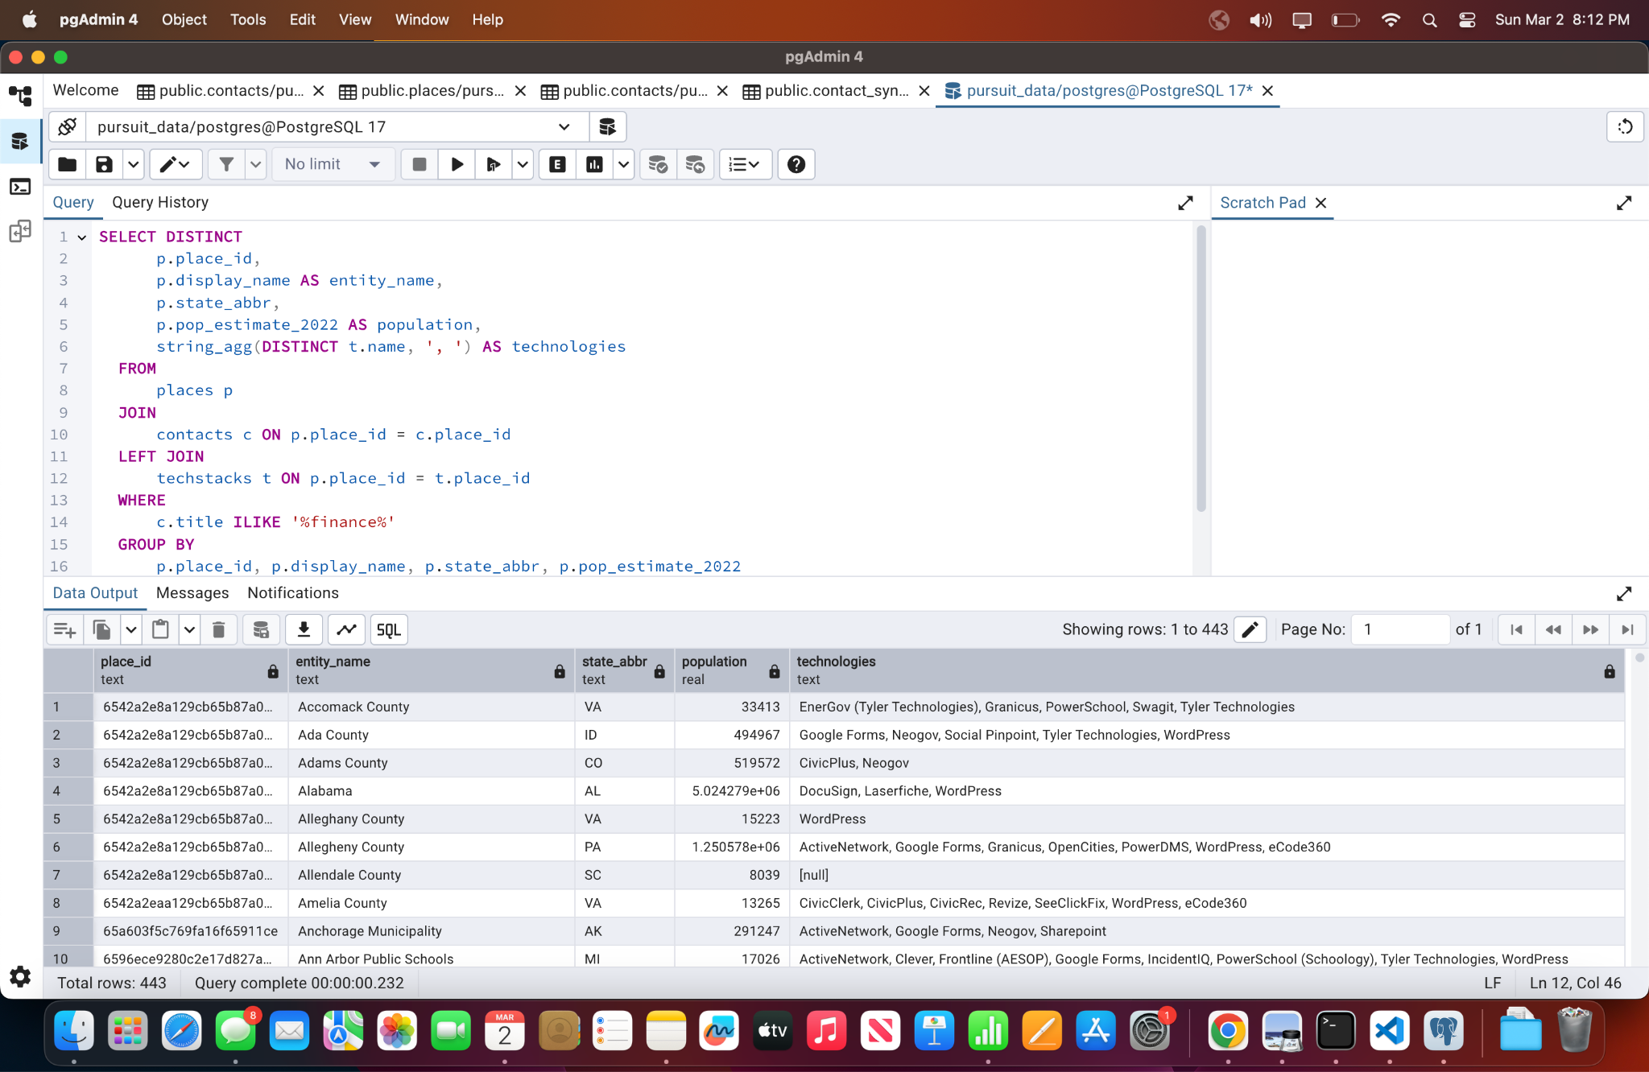

**2. Show me all contacts where an email contains bob and entity has technology “Accela” and population > 10k**

SELECT

c.contact_id,

c.first_name,

c.last_name,

c.emails,

c.phone,

c.title,

p.display_name AS entity_name,

p.pop_estimate_2022 AS population

FROM

contacts c

JOIN

places p ON c.place_id = c.place_id

JOIN

techstacks t ON p.place_id = t.place_id

WHERE

c.emails ILIKE '%bob%'

AND t.name = 'Accela'

AND p.pop_estimate_2022 > 10000;

-- Query 3: Find all entities synced with a specific customer's CRM

SELECT

p.place_id,

p.display_name AS entity_name,

p.state_abbr,

p.pop_estimate_2022 AS population,

cm.external_crm_id,

cm.account_owner,

string_agg(DISTINCT t.name, ', ') AS technologies

FROM

places p

JOIN

customer_mappings cm ON p.place_id = cm.place_id

LEFT JOIN

techstacks t ON p.place_id = t.place_id

WHERE

cm.customer_id = 'CustomerA'

GROUP BY

p.place_id, p.display_name, p.state_abbr, p.pop_estimate_2022, cm.external_crm_id, cm.account_owner;

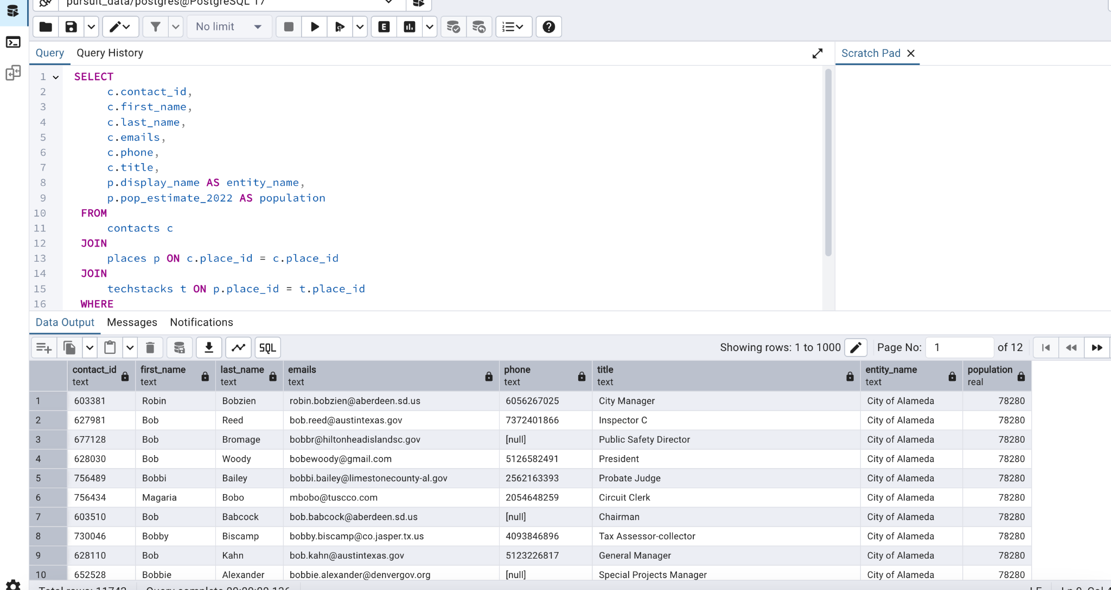

**3. Give me all entities that are synced w/ Customer A’s CRM.**

SELECT

p.place_id,

p.display_name AS entity_name,

p.state_abbr,

p.pop_estimate_2022 AS population,

cm.external_crm_id,

cm.account_owner,

string_agg(DISTINCT t.name, ', ') AS technologies

FROM

places p

JOIN

customer_mappings cm ON p.place_id = cm.place_id

LEFT JOIN

techstacks t ON p.place_id = t.place_id

WHERE

cm.customer_id = 'Customer_A'

GROUP BY

p.place_id, p.display_name, p.state_abbr, p.pop_estimate_2022, cm.external_crm_id, cm.account_owner

ORDER BY

p.display_name;

